MAGARARU, JOANNE S.

BSIT 2F21

EXERCISES 1

1. Create a new database called addressbook
CREATE DATABASE addressbook;

2. Which statement is used to list the information about a table? How do you use this statement?
Statement: DESCRIBE or DESC
Usage:

DESCRIBE employee_data;
or
DESC employee_data;

3. How would you list all the databases available on the system?
SHOW DATABASES;

4. Write the statement for inserting the following data in employee_data table
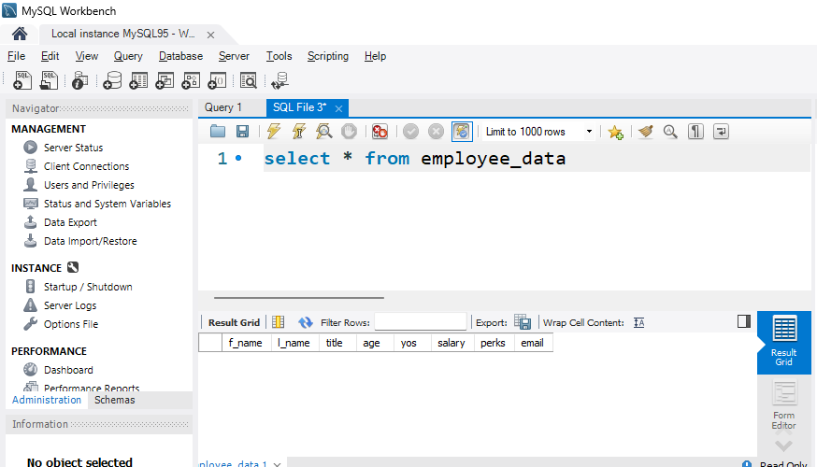
Given data:
First name: Rudolf
Last name: Reindeer
Title: Business Analyst
Age: 34
Years of service: 2
Salary: 95000
Perks: 17000
Email: rudolf@bugnet.com
SQL statement:
INSERT INTO employee_data (f_name, l_name, title, age, yos, salary, perks, email)VALUES ('Rudolf', 'Reindeer', 'Business

Analyst', 34, 2, 95000, 17000, 'rudolf@bugnet.com');

5. Give two forms of the SELECT statement that list all data in employee_data table
SELECT * FROM employee_data;or SELECT f_name, l_name, title, age, yos, salary, perks, email FROM employee_data;ss

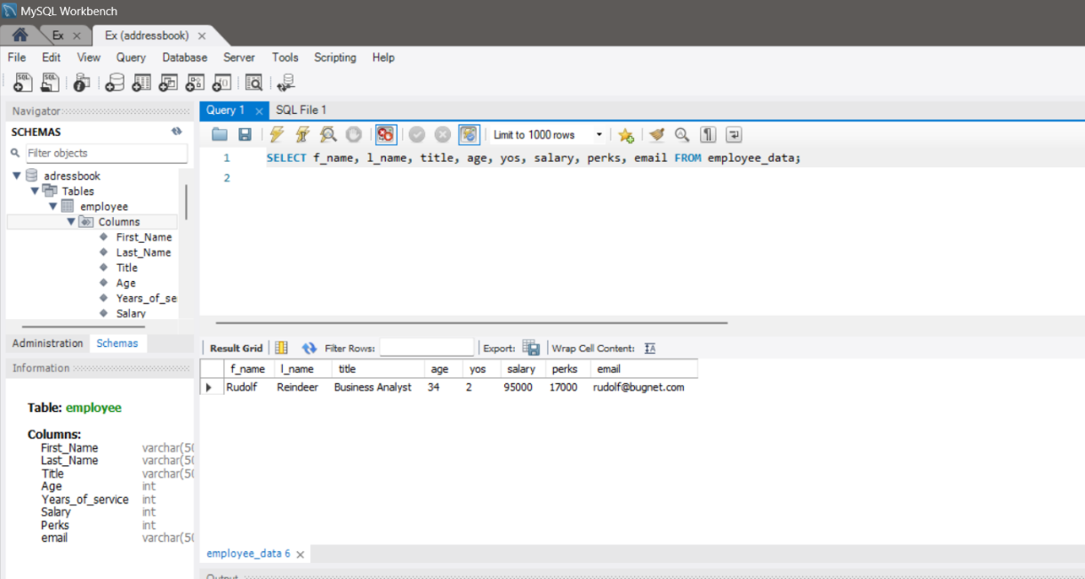

What will SELECT f_name, email FROM employee_data; display
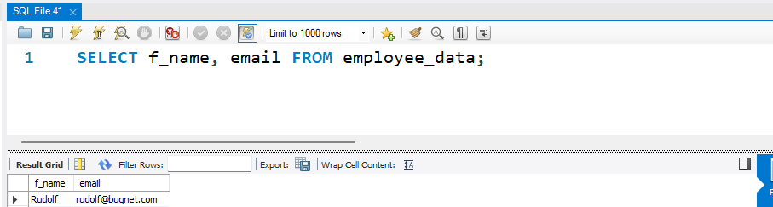
It will display only the first name and email address of all employees in the employee_data table.

7. Write the statement for listing data from salary, perks, and yos columns
SELECT salary, perks, yos FROM employee_data;

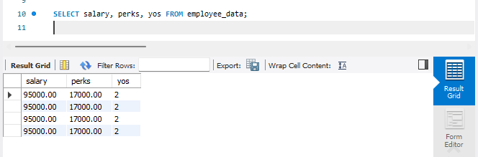

8. How can you find the number of rows in a table using the SELECT statement?
SELECT COUNT(*) FROM employee_data;
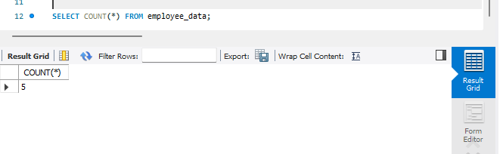

9. What will SELECT salary, l_name FROM employee_data; display?
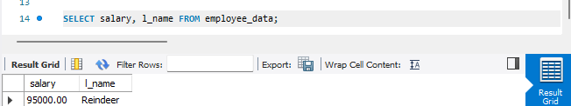
It will display the salary and last name of all employees in the employee_data table.

